

19P0012 AITZAZ TAHIR CH

DATA BASE LAB 06 SIR MUHAMMAD USMAN



**Task 6.1 Create the EMP_WORKED view.**

CREATE VIEW EMP_WORKED AS SELECT E.EMP_LNAME, E.EMP_FNAME, H.ATTRACT_NO,H.DATE_WORKED FROM employee E JOIN hours H ON E.EMP_NUM = H.EMP_NUM;

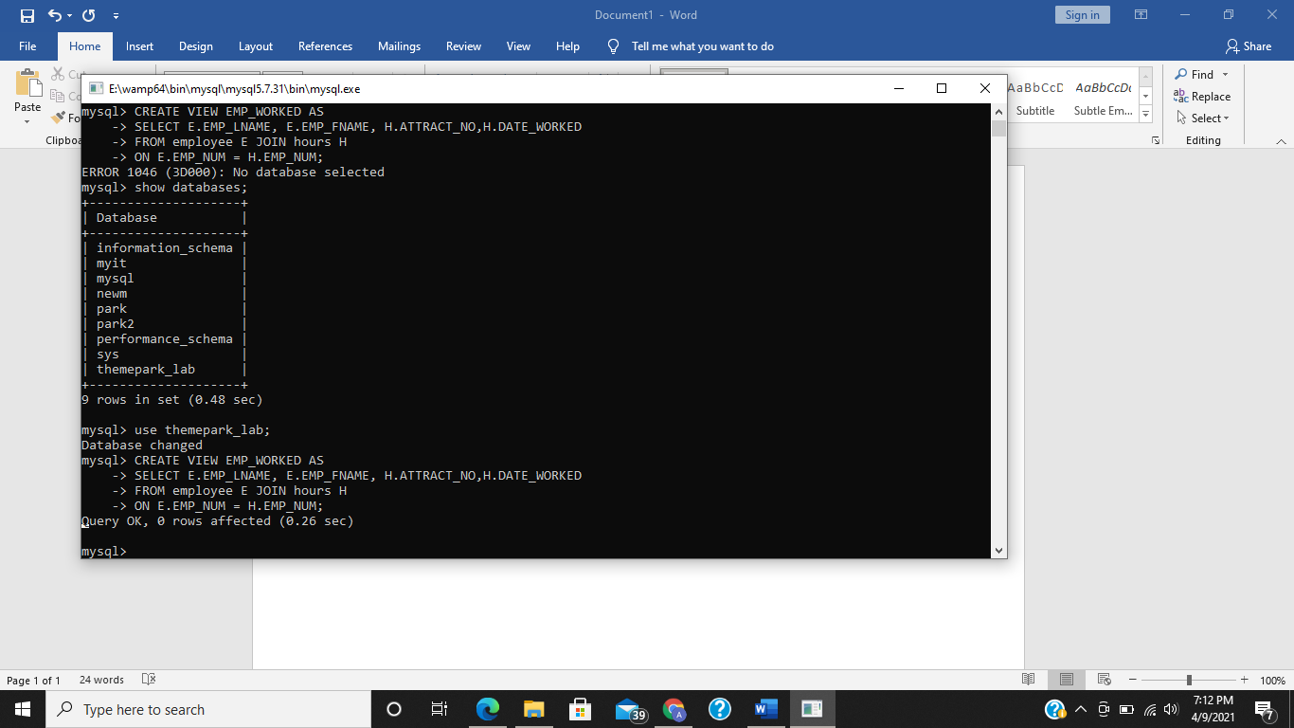

SELECT * FROM EMP_WORKED;

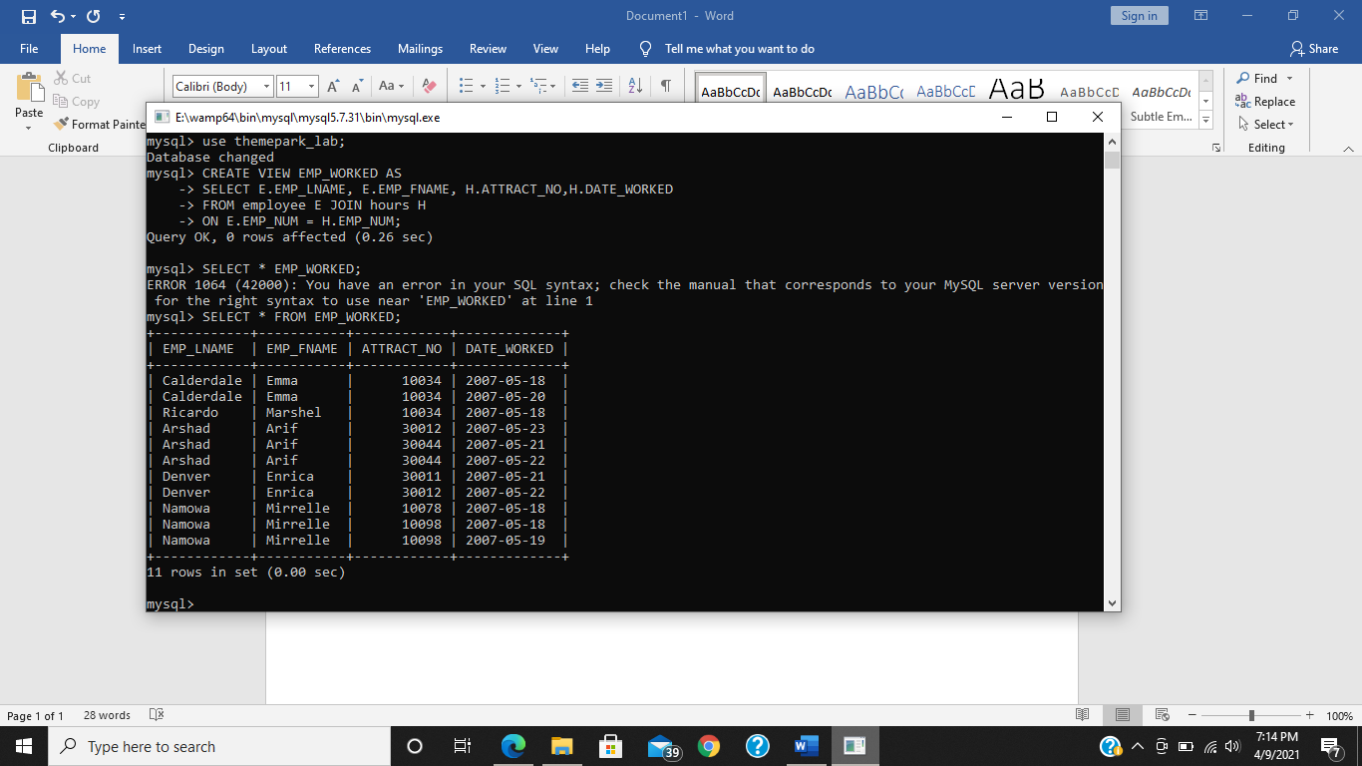

**Task 6.1 Enter the following query and examine how the date is displayed.**

SELECT DISTINCT(DATE_FORMAT(SALE_DATE, ‘%D %b %Y’)) FROM SALES;

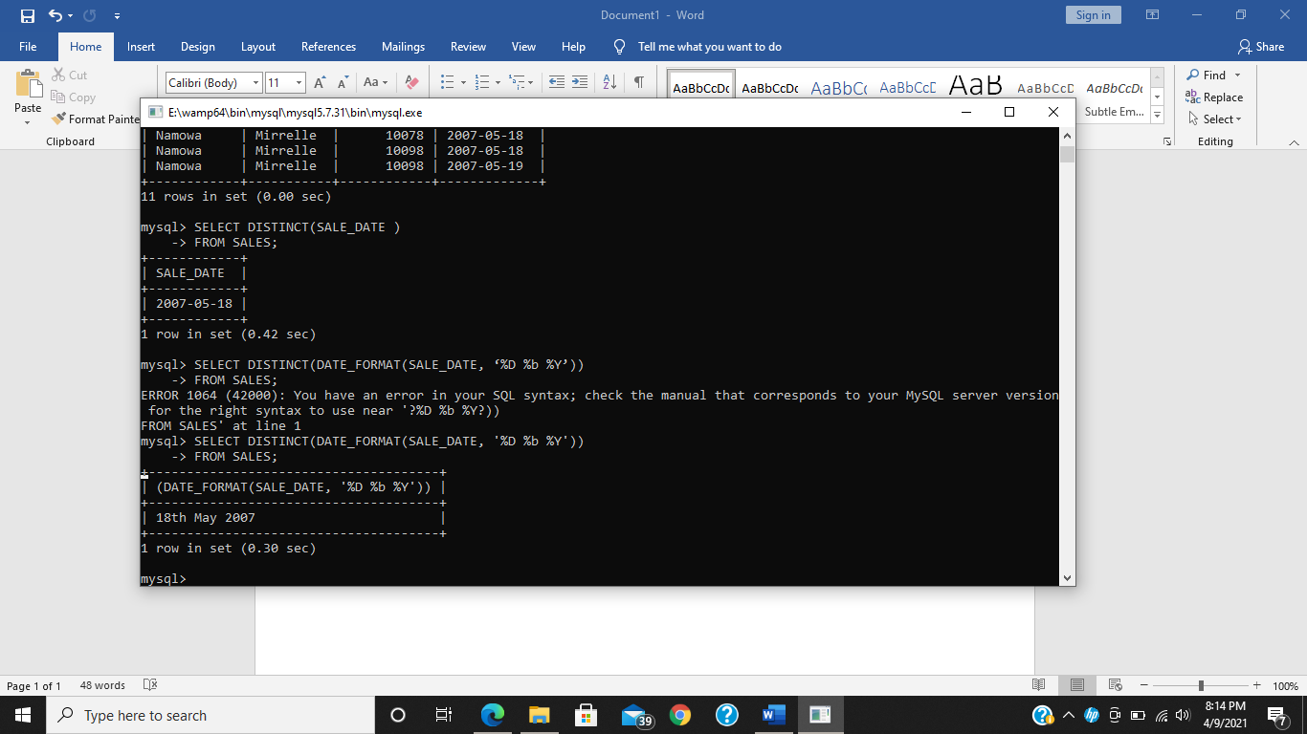

**Task 6.3 Enter the following query to display today’s date and time. Notice that in MySQL the functions are called using the SELECT statement but no FROM clause is needed.**

SELECT CURRENT_DATE(), CURRENT_TIME();

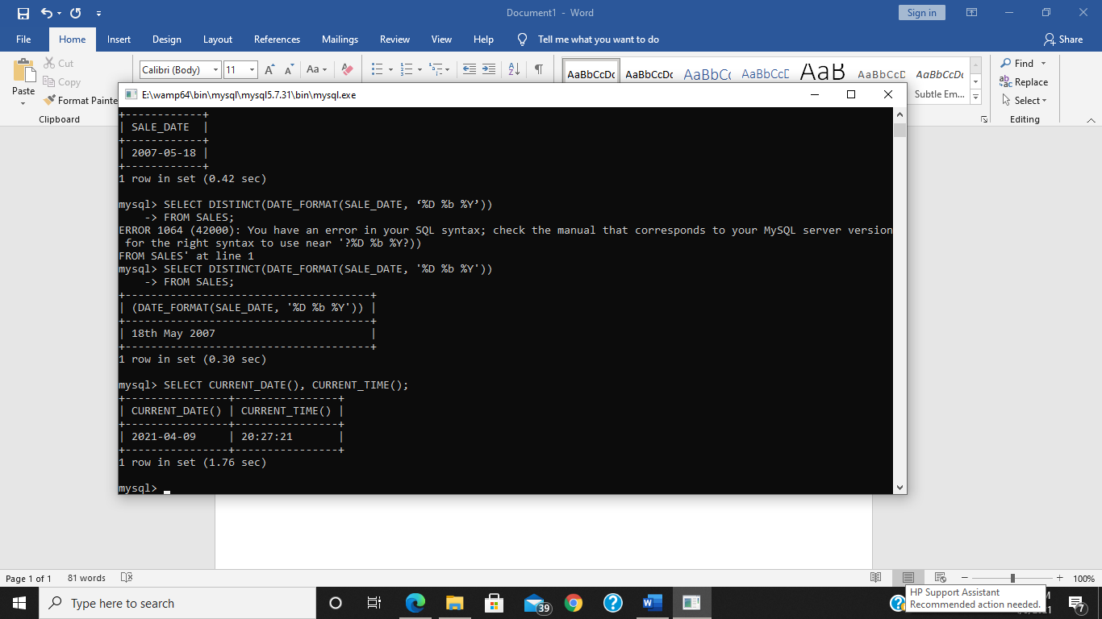

**Task 6.4 Write a query that displays all employees who were born in November**

SELECT EMP_LNAME, EMP_FNAME, EMP_DOB, DATE_FORMAT(EMP_DOB, '%b') AS MONTH

FROM EMPLOYEE WHERE MONTH(EMP_DOB) = '11';

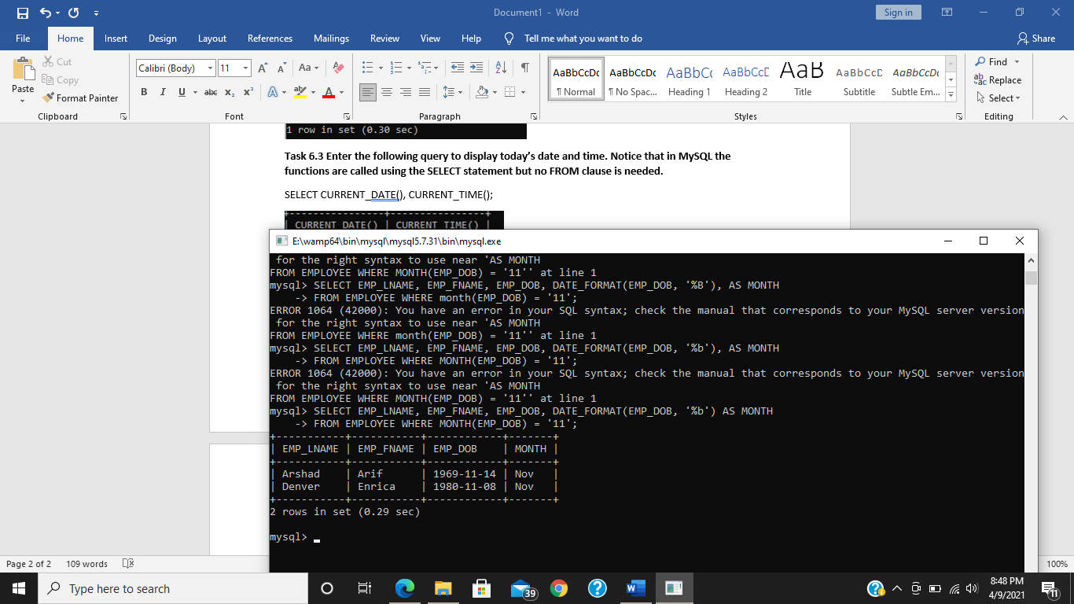

**Task 6.5 Enter the query above and see how many days it is until the 25th December.**

SELECT DATEDIFF('2008-12-25','2008-01-01');

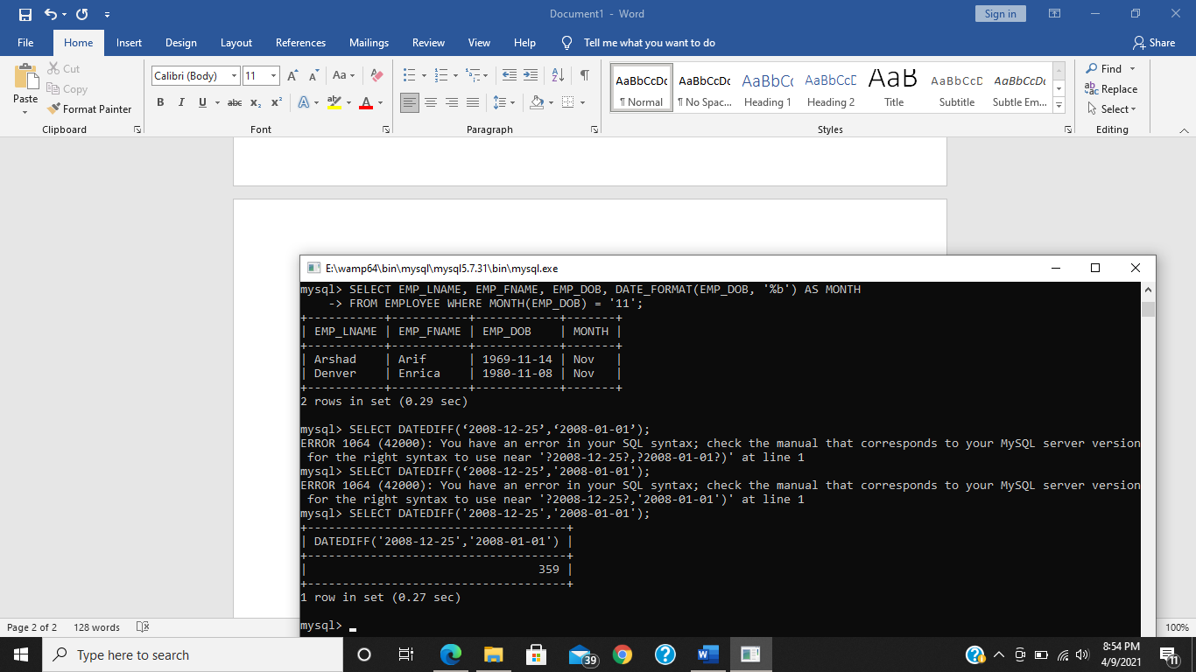

**Then modify the query to see how many days it is from today’s date until 25th December 2009.**

SELECT DATEDIFF(CURRENT_DATE(),'2009-12-25');

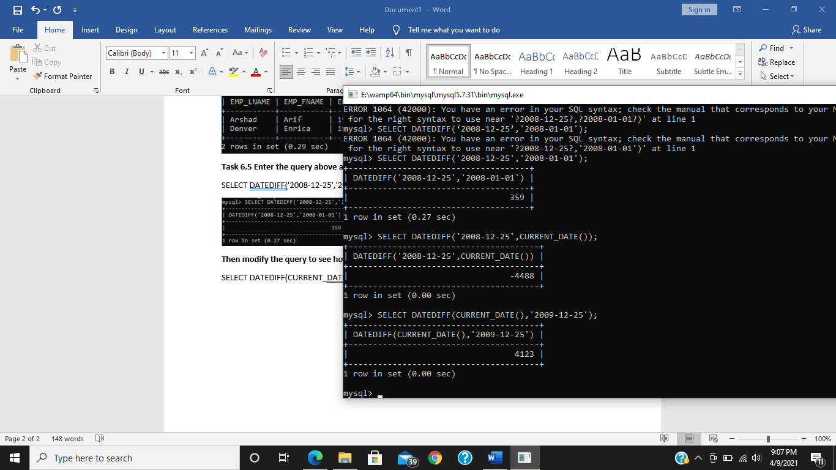

**Task 6.6 Enter the following query which lists the hire dates of all employees along with the date of their first work appraisal (one year from the hiredate). Check that the output is correct.**

SELECT EMP_LNAME, EMP_FNAME, EMP_HIRE_DATE, ADDDATE(EMP_HIRE_DATE, INTERVAL 12 MONTH )AS “FIRST APPRAISAL” FROM EMPLOYEE;

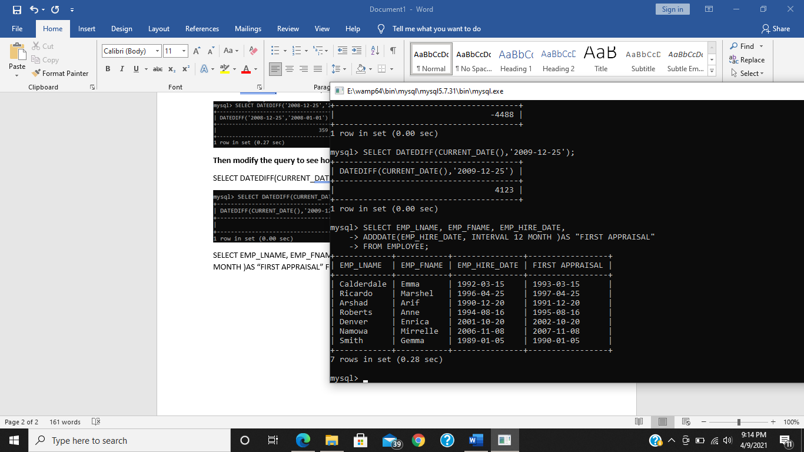

**Task 6.7 Enter the following query which lists all sales transactions that were made in the last 20 days of a month:**

SELECT * FROM SALES WHERE SALE_DATE >= LAST_DAY(SALE_DATE)-20;

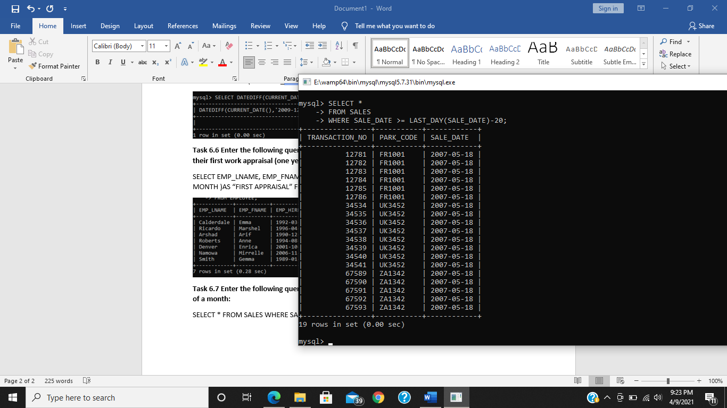

**Task 6.8 Enter the following query and execute it.**

SELECT TRANSACTION_NO, LINE_PRICE, MOD(LINE_PRICE, 10) FROM SALES_LINE WHERE LINE_QTY > 2;

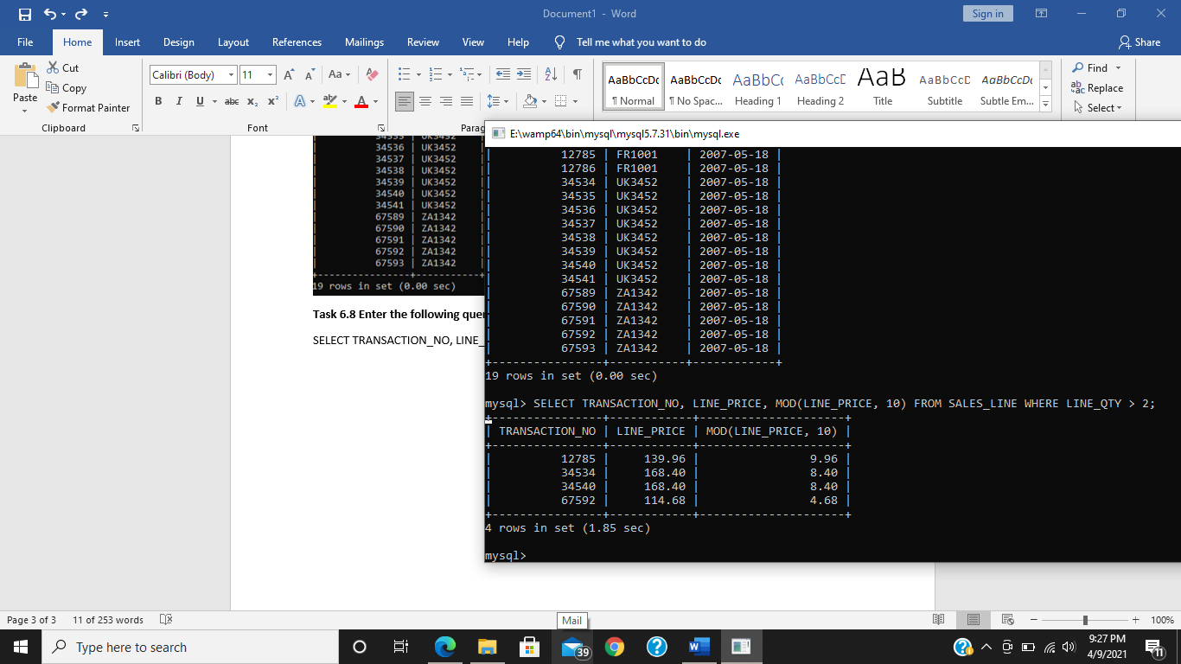

**Can you explain the results of this query?**

This query is displaying TRANSACTION_NO, LINE_PRICE and mod of LINE_PRICE and 10 from SALES_LINE table, where LINE_QTY > 2.

**Exercises:**

**E6.1 Create the view EMPFR (as created in section 6.2) and update the Theme Park that employee number 101 works in. (Update the employee number 101 information in the EMPFR view).**

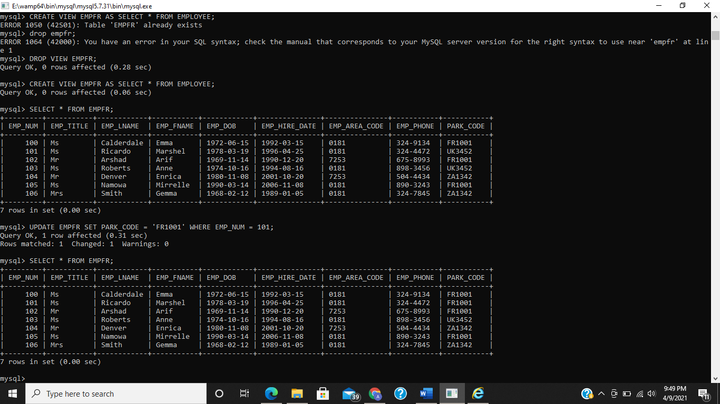

**E6.2 Employee Emma Cauderdale (EMP_NUM =100) has now changed her phone number to 324-9652. Update her information in the EMPFR view. Write a query to show her new phone number has been updated and then Remove the EMPFR view.**

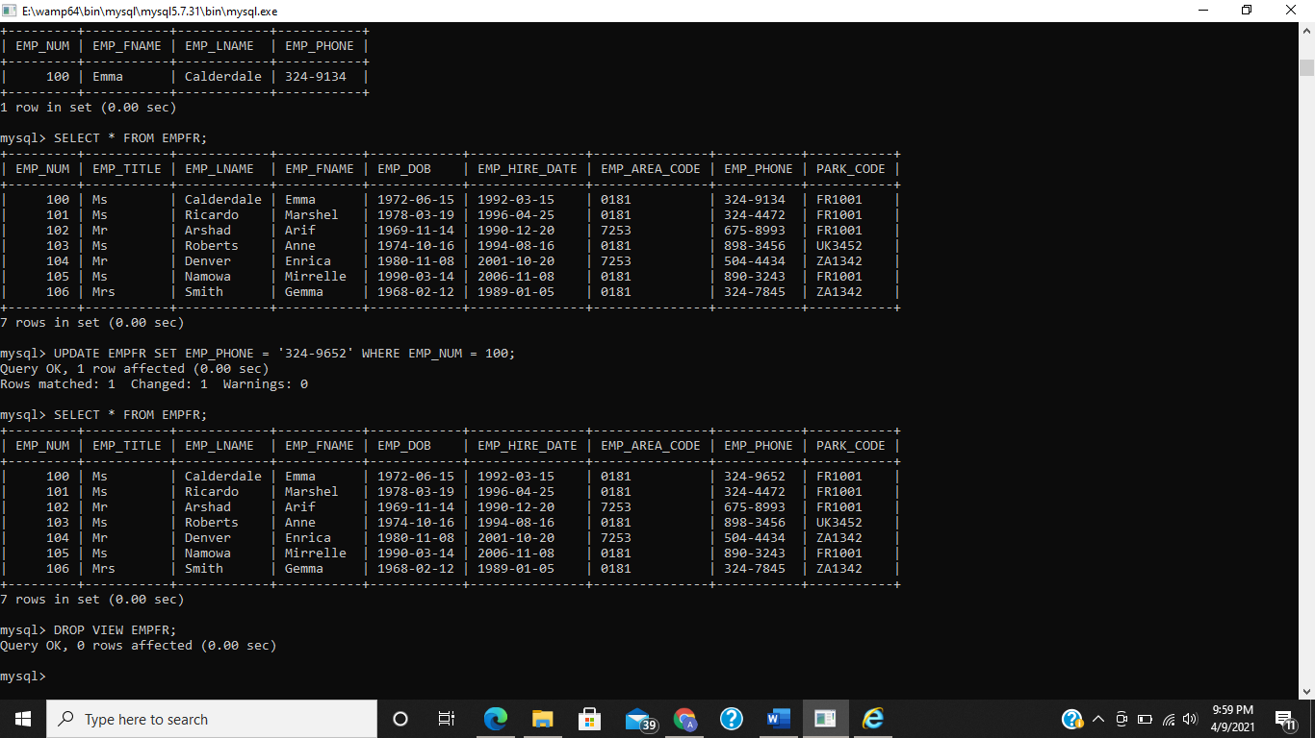

**E6.3 Create a view of only those Theme Parks where tickets have been sold and then display the contents of this view.**

CREATE VIEW TPARKSOLD AS SELECT DISTINCT PARK_CODE, PARK_NAME, PARK_CITY, PARK_COUNTRY FROM THEMEPARK NATURAL JOIN SALES;

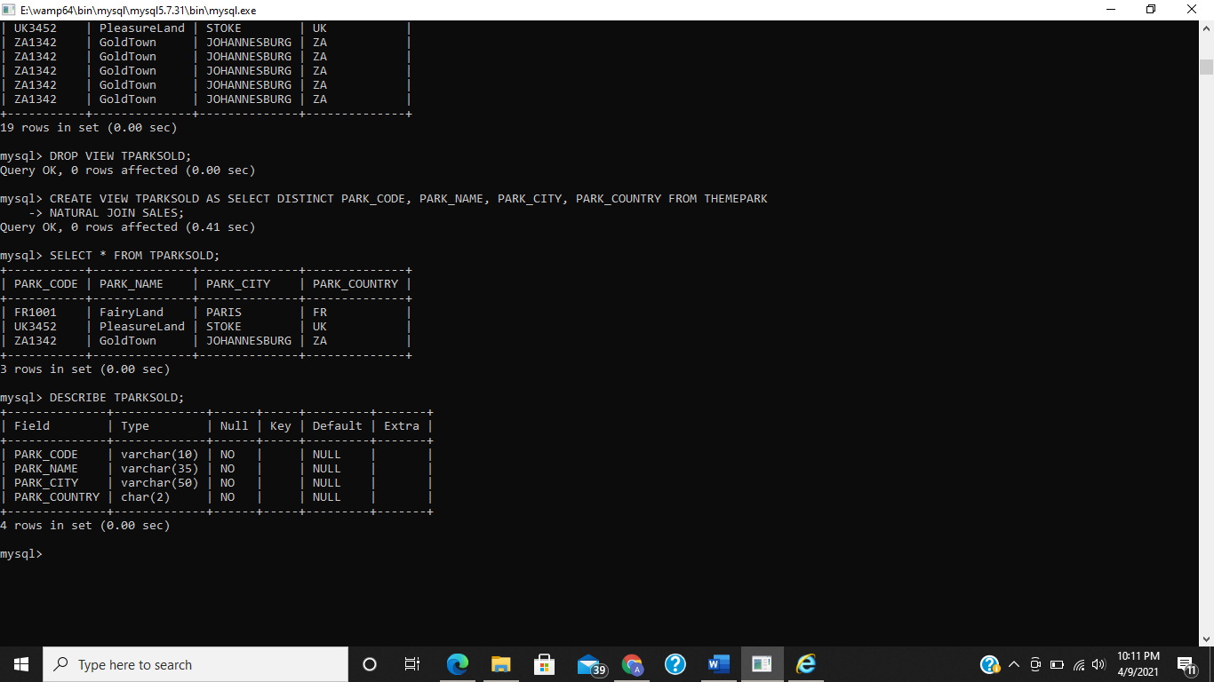

**E6.4 The Theme Park managers want to create a view called EMP_DETAILS which contains the following information. EMP_NO, PARK_CODE, PARK_NAME, EMP_LNAME_EMP_FNAME, EMP_HIRE_DATE and EMP_DOB. The view should only be read only. Check that the view works, by displaying its contents.**

CREATE VIEW EMP_DETAILS AS SELECT EMP_NUM, PARK_CODE, PARK_NAME, EMP_FNAME, EMP_LNAME, EMP_HIRE_DATE, EMP_DOB FROM EMPLOYEE NATURAL JOIN THEMEPARK WITH CHECK OPTION;

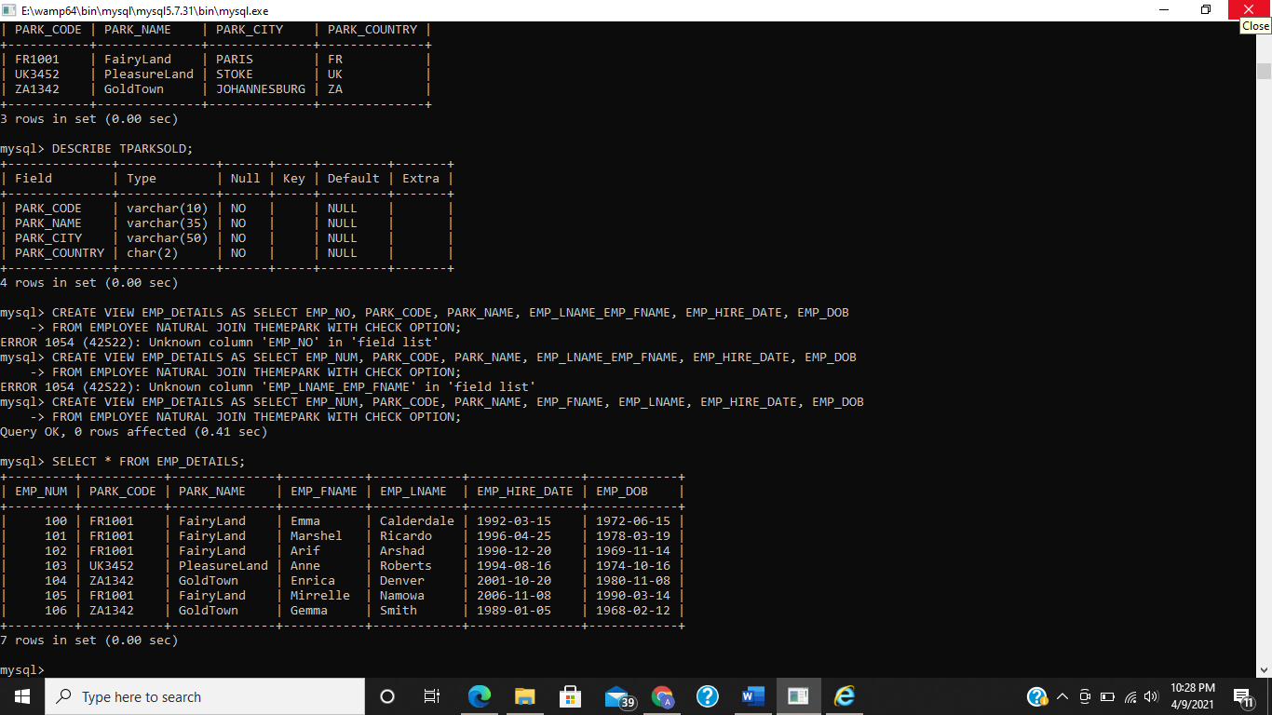

**E6.5 Using your view EMP_DETAILS, write a query that displays all employee first and last names and the park names.**

SELECT EMP_FNAME, EMP_LNAME, PARK_NAME FROM EMP_DETAILS;

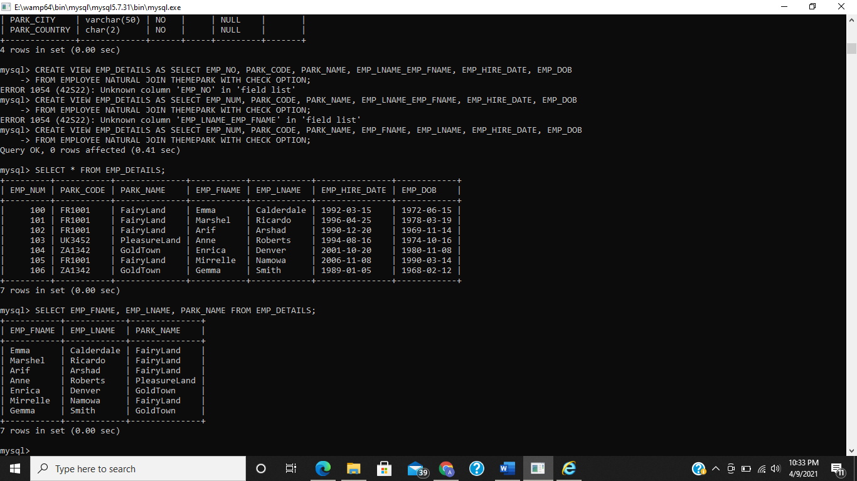

**E6.6 Create a view called TICKET_SALES which contains details of the min, max and average sales at each Theme Park. The name of the theme park should also be displayed.**

CREATE VIEW TICKET_SALES AS SELECT PARK_NAME, MIN(LINE_PRICE), MAX(LINE_PRICE), AVG(LINE_PRICE) FROM THEMEPARK NATURAL JOIN (SALES NATURAL JOIN SALES_LINE) GROUP BY PARK_CODE;

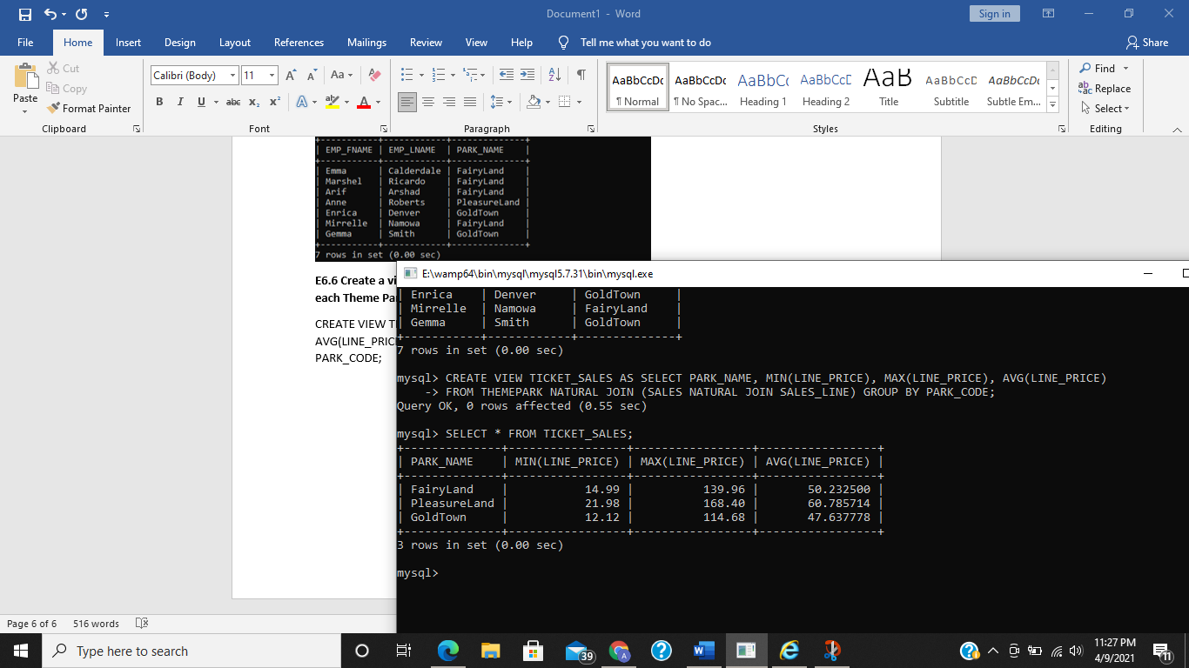

**E6.7 Using the date specifiers in Table 7.2, modify the query shown in Figure 55 to display the date in the format ’Fri – 18 – 5 – 07’.**

SELECT DISTINCT DATE_FORMAT(SALE_DATE, '%a - %d - %m - %y') from sales;

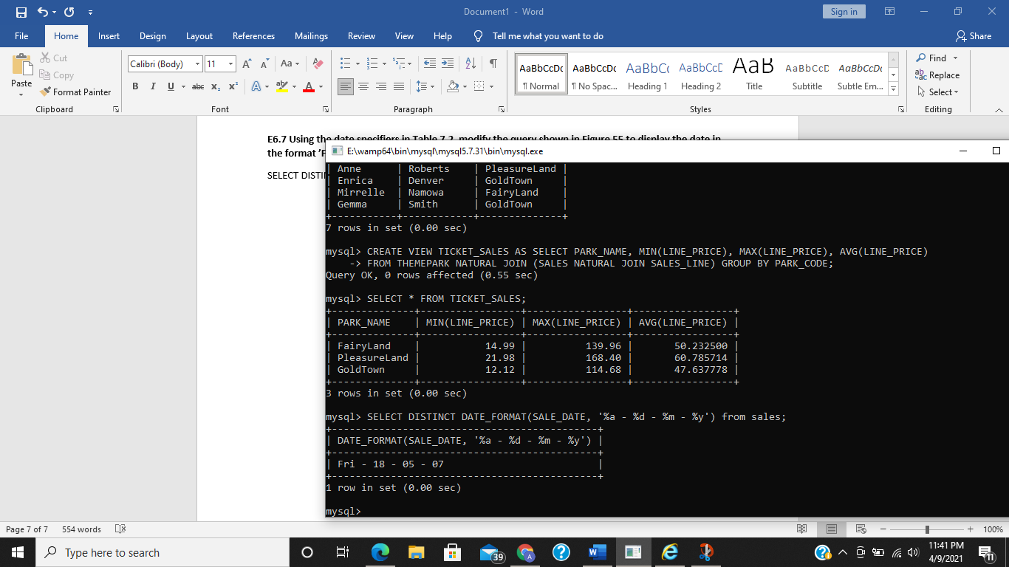

**E 6.8 Write a query which generates a list of employee user IDs, using the born month, first day of the month they were born and the first six characters of last name in UPPER case. Your query should return the results shown in Figure 64. USER ID format (MDName) here M= month, D= first day of month, Name= Employee last name first 6 alphabets.**

SELECT EMP_FNAME, EMP_LNAME, CONCAT(DATE_FORMAT(EMP_DOB,'%m'),DATE_FORMAT(DATE_SUB(DATE_ADD(LAST_DAY(EMP_DOB),INTERVAL 1 DAY),INTERVAL 1 MONTH), '%d'),UPPER(SUBSTR(EMP_LNAME,1,6))) AS USER_ID FROM EMPLOYEE;

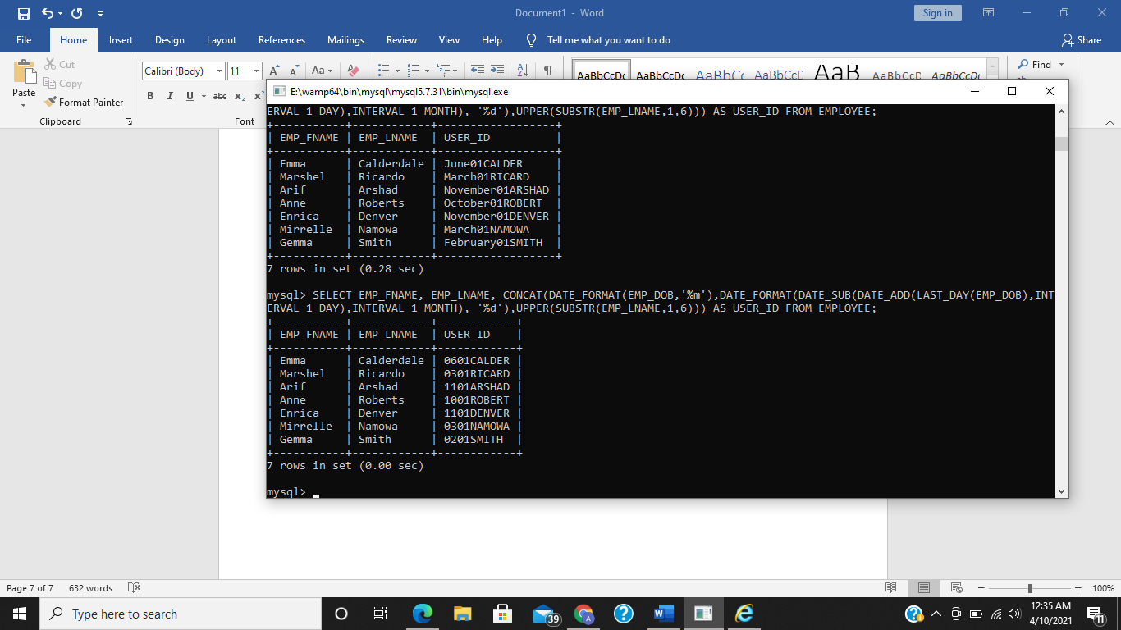

**E6.9 Write a query which lists the names and dates of births of all employees born on the 14th day of the month.**

SELECT CONCAT(EMP_FNAME, ' ', EMP_LNAME) AS EMPLOYEE_NAME, EMP_DOB FROM EMPLOYEE WHERE DAY(EMP_DOB) = '14th';

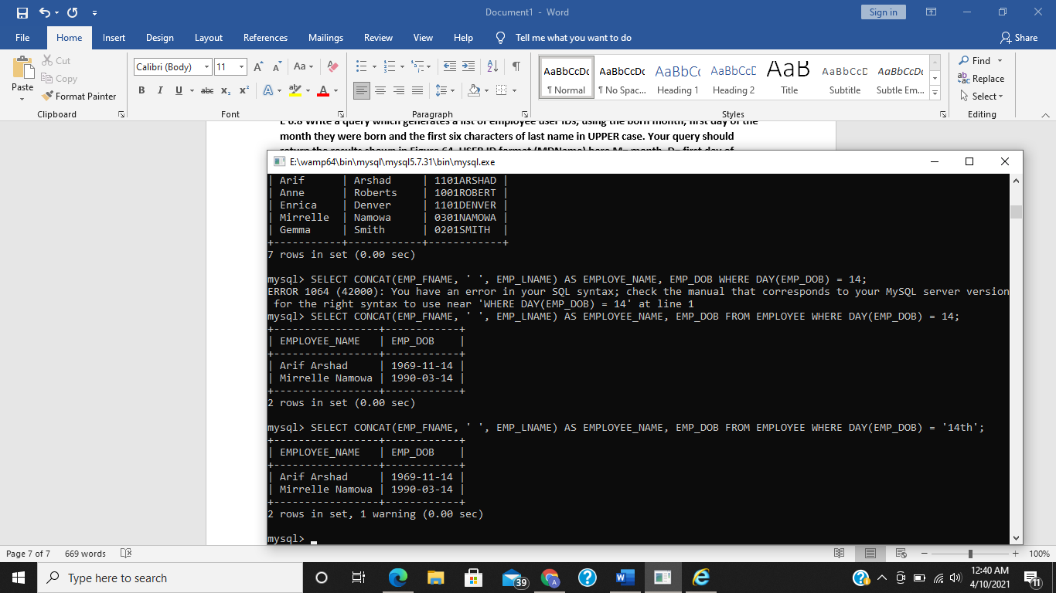

**E6.10 Write a query which generates a list of employee user passwords, using the first three digits of their phone number, and the first two characters of first name in lower case. Label the column USER_PASSWORD:**

SELECT CONCAT(SUBSTR(EMP_PHONE,1,3),LOWER(SUBSTR(EMP_FNAME,1,2))) AS USER_PASSWORD FROM EMPLOYEE;

